Computer Networking Simulation

Following is the SS of the Graphic User Interface (GUI)

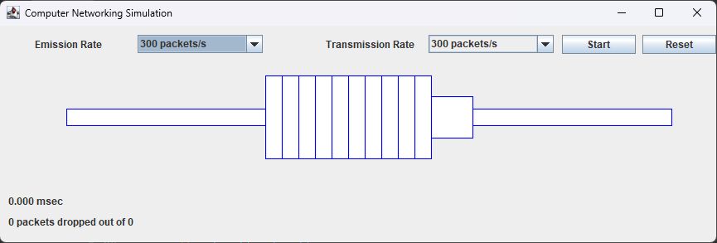

Here the borders of the network buffer and the links are kept blue. This can perform the simulation for the following 3 scenarios.

1. Emission Rate > Transmission Rate
2. Emission Rate = Transmission Rate
3. Emission Rate < Transmission Rate

This simulation is to demonstrate and to see what would happen if the data is sent at a different than the link capacity.

# Scenario 1

Emission Rate > Transmission Rate

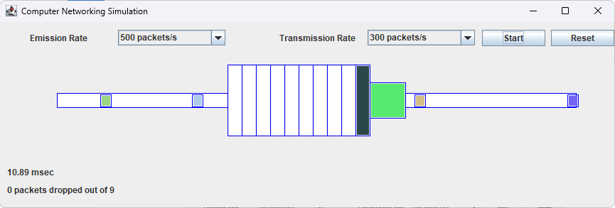

Packets are dropped,

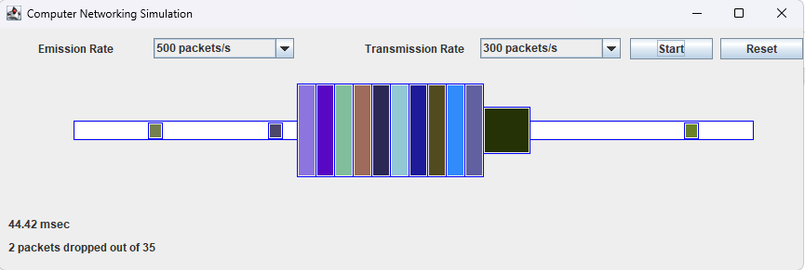

Here as can be seen from the above image, there are packets that are dropping. And it is also animated. Here 2 packets were dropped out of the 35 because the buffer is full.

Now in the following case, both are kept same,

# Scenario 2

Both rates are the same

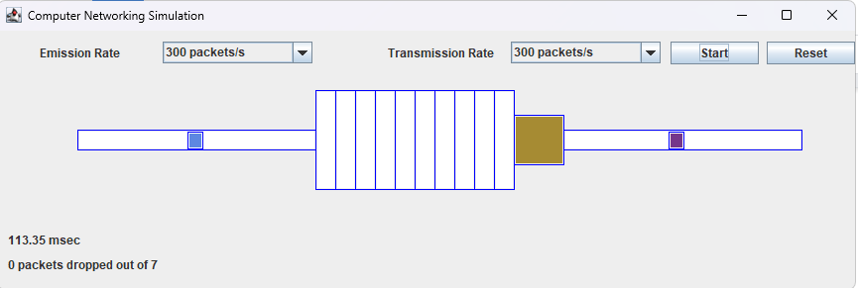

Here both are kept the same and now it’s working fine without dropping any packets. However, it is also not utilizing the available buffer capacity. So transmission could be a bit slower or emission could be faster.

# Scenario 3

In this scenario the transmission rate is much higher than the emission rate, this will further reduce the utilization of the system.

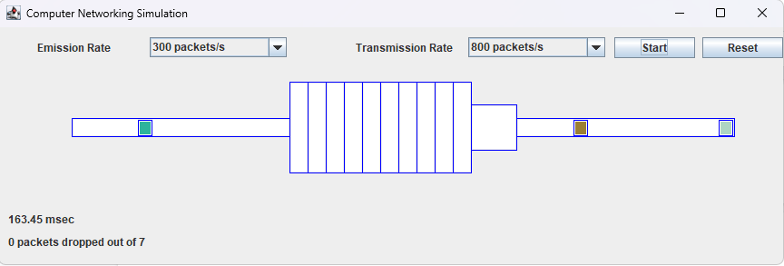

This shows that the simulation is demonstrating the behavior of the packets in different conditions.

**Examples of the simulation working.**

1. The emission rate is equal to the transmission rate.

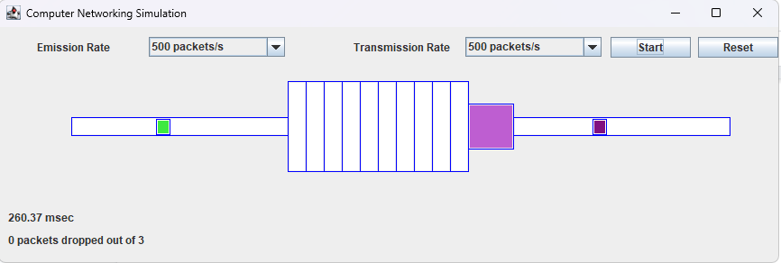

1. The emission rate is less than the transmission rate, the packets don't have to be queued

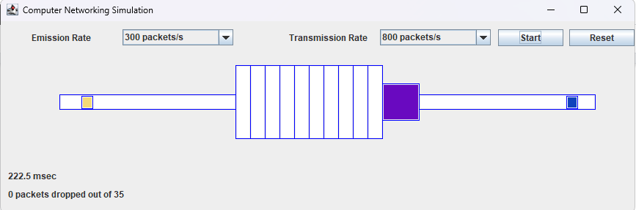

1. A timer in milliseconds indicates the time the packets take to transmit.

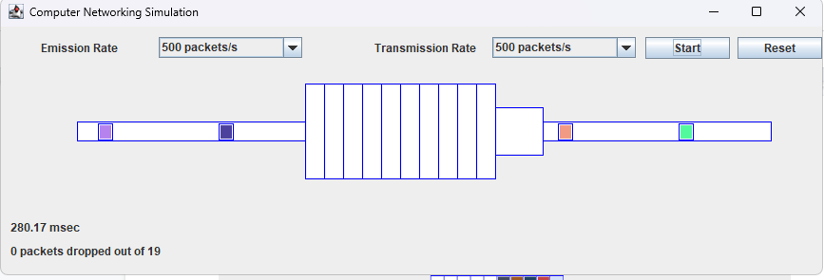

1. the queue is full and extra packets are dropped

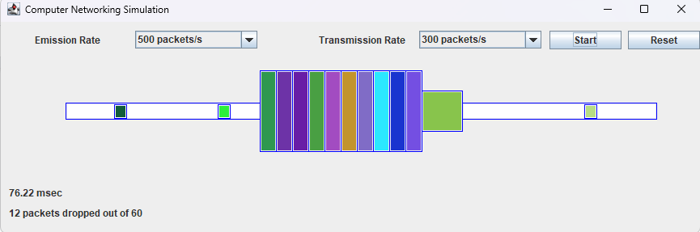

1. Packets dropped and successful packets indicators

